
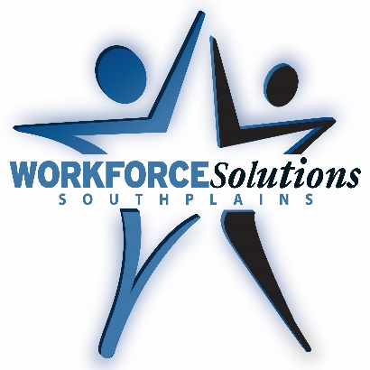

Youth Job Fair 2022
Thursday, May 19, 2022 – 4:00 p.m. to 7:00 p.m.
MCM Elegante Hotel & Suites – 801 Avenue Q, Lubbock, TX 79401

EMPLOYER REGISTRATION FORM
How many employee candidates are you looking for?
Company Name:
Company Contact:
Company Address:
Phone #: Fax #:
Contact Email:
- Set Up Time: 2:00 p.m. to 4:00 p.m. the day of the job fair (May 19, 2022)
- This is a free event with limited space. Each employer will receive one booth.
- Electrical outlets will be available. Please bring an extension cord if necessary.

Please submit this completed registration form to Kimberly Brown via email at Kimberly.brown@spworkforce.org or by fax to (806) 608-8362. You can also mail it or bring it in person to 2002 W Loop 289, Suite 117, Lubbock, TX 79407.
For an online employer registration application, please follow this link:
https://sql-web-srv.spworkforce.org/Forms/YouthJobFairReg

THANK YOU FOR YOUR PARTICIPATION!

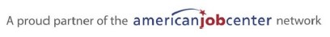
REGISTRATION DEADLINE IS THURSDAY, MAY 5, 2022 BY 5PM.

