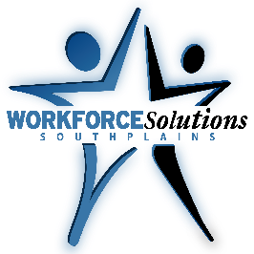

WORKFORCE SOLUTIONS SOUTH PLAINS
YOUTH CAREER FAIR

*** WEDNESDAY MARCH 14, 2018 ***
Our annual event will focus on youth ages 14 -24, looking for full or part-time employment or training.
We anticipate having approximately 1,500 in attendance for this event.
FREE BOOTH REGISTRATION! Please complete the Booth Registration Form below now to reserve your spot! Return it to Workforce Solutions South Plains as soon as possible, but no later than MARCH 1st, 2018 to sign up for this free and exciting event.
- 8:00 a.m. to 9:45 a.m. – Vendor Setup
- 9:45 a.m. Ribbon Cutting provided by Lubbock Chamber of Commerce
- 10:00 a.m. to 2:00 p.m. - Event start and end time.
Please return form to ISABEL DOTSON via E-mail Isabel.dotson@spworkforce.org or Fax: (806) 776-1715; for questions or more information, call (806) 765-5038 ask for Youth Services or go to www.spworkforce.org
Date: Wednesday, March 14, 2018
Time: 10:00 a.m. to 2:00 p.m. Location: Lubbock Memorial Civic Center
1501 Mac Davis Lane, Lubbock, TX 79401

All Registration forms should be received by March 1, 2018 to reserve a booth.
CANCELLATION DEADLINE: March 7, 2017
Name of Business/Organization: _______________________________________________________________________________
Contact: _______________________________________________________ Phone: ___________________________________________
Mailing Address: _________________________________________________________________________________________________
City: ___________________________________________ State: ______ Zip Code: _______________________________________
Email Address: ___________________________________________________________________________________________________
Number of Representatives Attending _________(Registration includes light refreshments and 2 boxed lunches)
Special accommodations: _____________________________________________________________________________________

- Please indicate if your organization hires 14 or 15-year-old individuals? Yes or No

- Workforce Solutions South Plains will be partnering with Vocational Rehabilitation to provide paid Work Experience opportunities to students with disabilities for 5 weeks during the summer. Please indicate if your organization would be interested in supporting our “Summer Earn and Learn” initiative for students with disabilities? Yes or No

