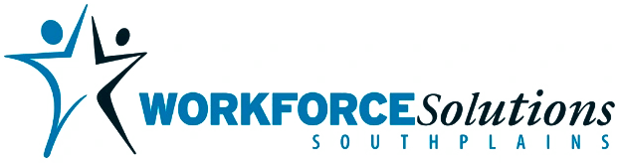
Workforce Solutions South Plains Board (the Board) is soliciting proposals from qualified and eligible entities for the operation and management of local workforce center services and the related programs/initiatives established by the Board, which has oversight of workforce activities in Bailey, Cochran, Crosby, Dickens, Floyd, Garza, Hale, Hockley, King, Lamb, Lubbock, Lynn, Motley, Terry, and Yoakum counties.
The Board expects to enter into a relationship with a subrecipient for the operation and management of its workforce centers for WIOA Programs, and Child Care services as a result of this RFP. The initial contract will be for the Management and Operations of Workforce Services and Youth Programs is for a period of one year, beginning October 1, 2026, and ending September 30, 2027. Contract(s) may be extended for a one-year period on an annual basis at the discretion of the Board for up to three additional years based on satisfactory performance or other factors as determined by the Board. The contract for Child Care Services may be renewed on an annual basis after the initial contract period of October 1, 2026, through September 30, 2027, not to exceed four (4) years of annual renewals. Each annual renewal will be at the discretion of Workforce Solutions South Plains and based on successful performance of contractual obligations.
Services solicited in this RFP include the operation and management of the five workforce centers and quality services to employer and job seeker customers. Center operations will encompass the coordinated delivery of workforce programs and services consistent with local and state plans and applicable federal, state, and local laws, rules, regulations, policies, and directives.

